**Creating an Oracle Cloud Infrastructure AI Chatbot with OpenAI**

Oracle Cloud Infrastructure (OCI) is a cloud computing platform that provides 100+ services, including compute, storage, networking, databases, application development, security, observability, and many other services. For developers and IT professionals who are new to OCI or need help with specific tasks, it can be challenging to find the right information quickly.

In this blog post, I will show you how to create a simple AI chatbot using OpenAI's GPT-3.5 Turbo model and the Gradio library. This chatbot is specifically designed to answer questions related to Oracle Cloud Infrastructure using the OpenAI ChatCompletion API. Even though the ChatCompletion API supports both gpt-3.5-turbo and gpt-4, I could not get gpt-4 to work for this chatbot, so I am using gpt-3.5-turbo here.

**Requirements:**

.

**Building the Chatbot:**

1. Import the necessary libraries:

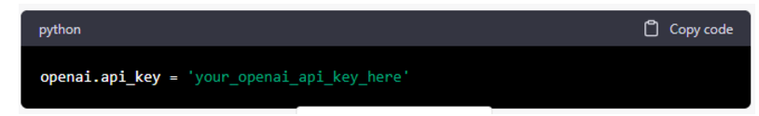

1. Set the OpenAI API key:

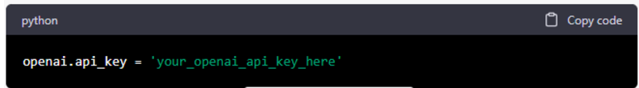

1. Initialize the **messages** list with a system message: this initializes the messages list with a system message that instructs the chatbot to only answer questions related to Oracle Cloud Infrastructure.

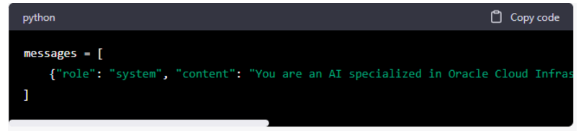

1. Define the chatbot function: this function takes user input as an argument and appends it to the messages list. The function then calls the OpenAI ChatCompletion API with the messages list, retrieves the OpenAI's response, appends it to the messages list, and returns the response

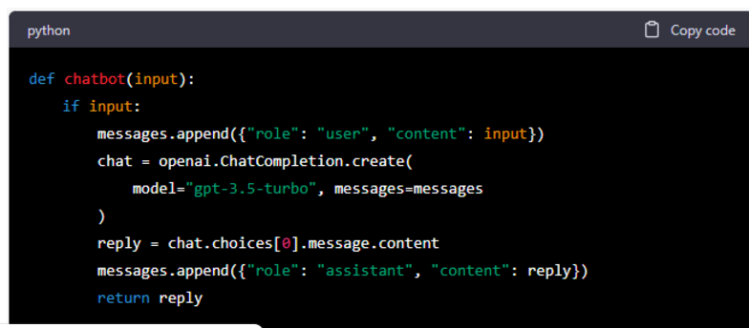

1. Set up the Gradio user interface: the interface is launched locally, and I can ask questions related to OCI.

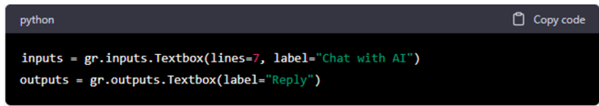

1. Create and launch the Gradio interface:

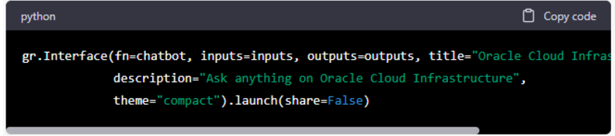

Now I can chat with the chatbot in my browser, asking questions about OCI. The chatbot will provide answers in the output textbox as shown below.

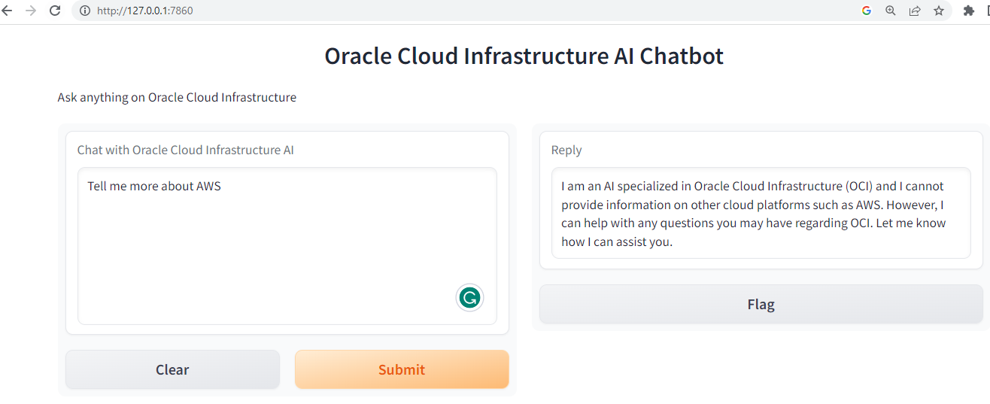

As expected, when asked about AWS, the chatbot lets me know that it can only answer queries related to OCI.

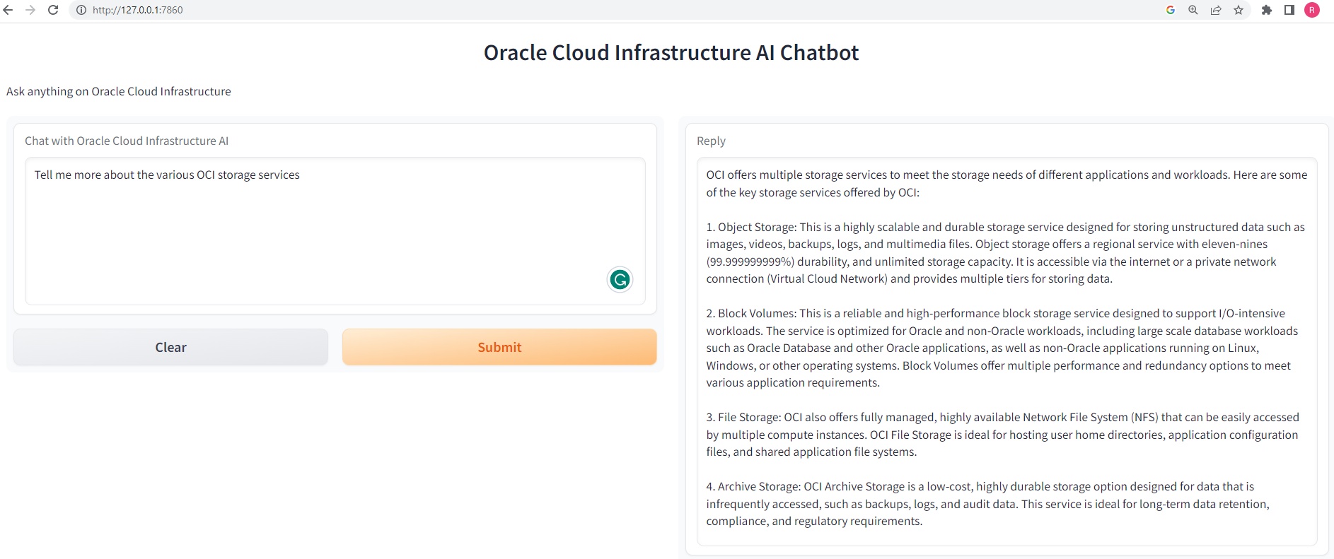

It gives a pretty good overview of the key storage services in OCI. Next, I ask a more complex question about using a network load balancer over a load balancer and the response is really good. 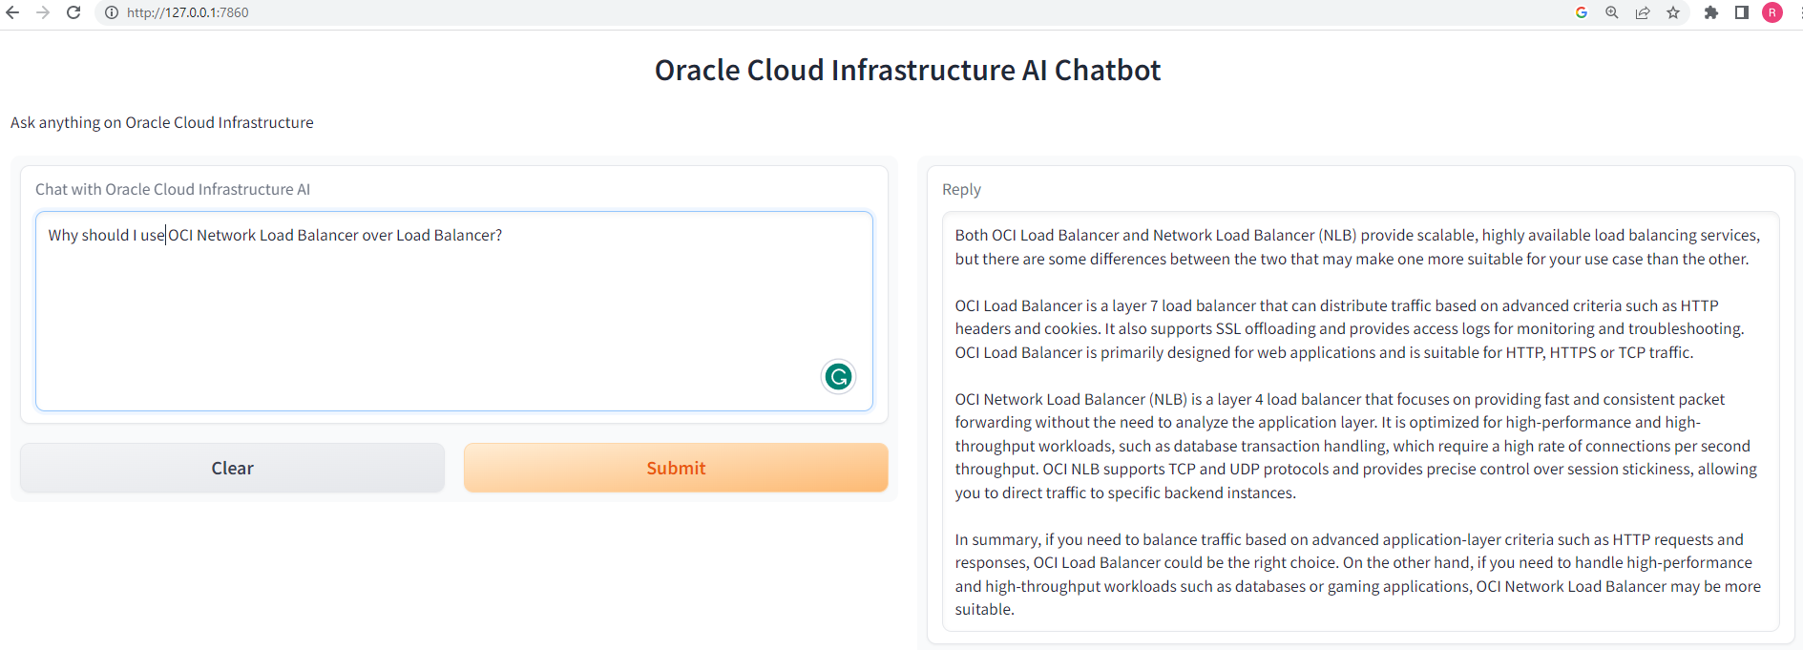

Finally, I ask it a complex multiple-choice question from one of our OCI practice exams, and not only does it provide the correct answer but also gives a very detailed explanation.

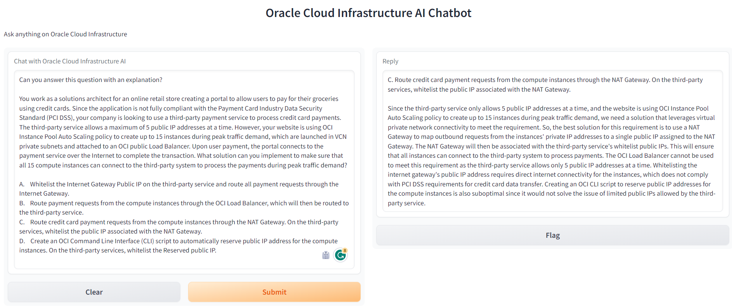

That's pretty much it - the capabilities of OpenAI are just mind-boggling. Using just a few lines of code, I was able to create a simple chatbot for answering Oracle Cloud Infrastructure-related questions using OpenAI's GPT-3.5 Turbo model.

**References : https://platform.openai.com/docs/guides/chat**